AI-Optimized Trim & Fuse for Derivative Chips
MCU · PMIC · Sensor · SoC
17 October 2026

Overview
AI can cut trim test time, improve first-pass trim accuracy and remove fuse-map errors across a chip family. It does this by predicting trim codes instead of searching for them, and by sharing models across derivatives through common IP blocks.
A derivative is a variant of a base die. It shares IP blocks such as bandgaps, oscillators, LDOs, ADCs and memories, but has different specs, fuse maps or enabled features.
Conventional flows have four recurring costs:
- Test time: iterative binary-search trim loops (measure, adjust, re-measure) take a large share of wafer-sort time.
- Duplicated engineering: the same IP trim is re-characterized for every derivative.
- Irreversible errors: fuses are one-time programmable (OTP), so a fuse-map mistake cannot be undone.
- Drift: parts shift between wafer sort and final test, so trims chosen at sort can land off target after packaging.
The approach in this document is the same for every chip type: shared IP-block models, transfer learning to derivatives, predict-then-verify on the tester, and drift-aware targets. What changes by chip type is which trims and fuses dominate and where AI pays off most.

Core AI techniques for all chip types
Nine techniques apply across the family. Predictive trim and transfer learning are the foundation; the rest build on the same data.
- Predictive (single-shot) trim. An ML model predicts the trim code from data already available: the untrimmed first measurement, process-monitor (PCM/e-test) data, wafer x/y and radius, lot and wafer history, and neighboring dies’ results. The tester applies the predicted code, takes one verification measurement, and runs a short local search only if the check fails. This typically replaces 6–10 search iterations with 1–2. Gradient-boosted trees or small neural networks are fast enough for real-time tester use.
- Transfer learning across derivatives. Organize models by IP block, not by product. Train a base model on the high-volume parent chip, then fine-tune it per derivative with a small set of characterization dies plus derivative features (supply domain, package, load). A new derivative gets a working model in days, not a full characterization run.
- Wafer-map spatial models. Trim codes correlate across the wafer. Gaussian-process (kriging) or CNN wafer-map models predict codes from a sparse sample of fully searched dies.
- Coupled multi-trim optimization. Trims interact (bandgap → LDO → oscillator/ADC references). Multi-output models predict all codes together; Bayesian optimization or reinforcement learning finds the best trim order and fewest measurements.
- Drift-aware targets. Models trained on sort-to-final and post-burn-in data predict package shift, so sort trims to an offset target and the part lands centered after assembly.
- Fuse-map generation and validation. One source-of-truth fuse schema per family; derivatives inherit and override. Fuse maps and test code are generated from the spec (LLM-assisted generators paired with rule checks) and checked for overlapping bits, wrong polarity, missing lock bits and feature conflicts.
- Die-to-SKU assignment. When one die can be fused as several derivatives, ML predicts per-die performance and an optimizer (linear or integer programming) picks the SKU to maximize revenue against demand within guard bands.
- Memory repair allocation. Optimization solvers or ML choose redundancy rows and columns better than greedy algorithms, raising repairable yield with the same fuses.
- Anomaly screening. Dies whose trim code sits at the range edge, or whose predicted and measured values disagree strongly, are flagged as likely latent defects.

Comparison by chip type
The biggest AI win differs by chip type: oscillator trim for MCUs, coupled rails for PMICs, fewer temperature insertions for sensors, and binning for SoCs.
Chip type | Typical derivatives | Main trims | Main fuses | Biggest AI win
MCU | Flash/RAM size, pin count, peripherals, temperature grade | Bandgap, RC oscillators, LDO, ADC/DAC, temperature sensor | Memory size, peripheral enables, security/lock bits, repair | Predictive oscillator/bandgap trim; fuse-map generation across many SKUs
PMIC | Default rail voltages, power-up sequence, I²C address, customer OTP | Output voltages, current limits, OVP/UVLO thresholds, oscillator, current-sense gain | Rail defaults, sequence, I²C address, customer OTP config | Coupled multi-rail trim; customer OTP configuration management
Sensor | Range (e.g. ±2g/±16g), output type, package | Offset, gain, temperature coefficients, linearity, ASIC reference | Calibration coefficients, range/ODR config, part ID | Multi-temperature calibration from fewer insertions
SoC | Speed/power bin, disabled cores or features, cache, package | AVS/voltage bins, PLL, DDR PHY/IO impedance, thermal sensors, SRAM Vmin | Speed bins, core/feature disable, memory repair, security keys | Binning and harvesting optimization; repair allocation

MCU
For MCUs, the quickest win is single-shot oscillator and bandgap trim, and the biggest risk is a wrong fuse bit across dozens of SKUs.
Typical derivatives: one die sold with different flash/RAM sizes, pin counts, peripherals or temperature grades, often dozens of SKUs per family.
AI applications
- Single-shot trim for the bandgap, high- and low-speed RC oscillators (HSI/LSI), LDO, ADC offset/gain and temperature-sensor calibration. Features: untrimmed reading, PCM, wafer x/y, neighboring dies.
- One base model per IP block. Every derivative uses the same oscillator, so each package or temperature grade needs only a small fine-tune.
- Temperature-sensor calibration: predict the hot calibration point from room-temperature data, which can remove a test insertion.
- Fuse-map automation: generate fuse maps from the SKU spec matrix and verify them automatically, covering:
  - memory-size bits
  - peripheral enables
  - read-protection and debug-lock bits
  - ECC and repair fields
- Flash/SRAM repair allocation with an optimization solver.
Cautions: security fuses (debug lock, secure boot) always get rule-based checks. A mistake can brick the part or leave it insecure.

PMIC
For PMICs, AI pays off most by trimming all rails together from one reference measurement and by generating customer OTP images safely.
Typical derivatives: one die with different default rail voltages, power-up sequences or I²C addresses, often customized per customer through OTP.
AI applications
- Coupled multi-rail trim: buck/LDO outputs share the bandgap reference and interact through supply and load. A multi-output model predicts every rail’s code together, often from one reference measurement plus PCM.
- Threshold trims (OVP, UVLO, current limit, power-good) predicted from the reference trim result and device parameters.
- Current-sense gain and offset predicted from a two-point measurement instead of a full sweep.
- Drift-aware targets: the model learns the package-stress shift of the reference and trims to an offset at sort.
- Customer OTP configuration management: a schema-driven generator turns a customer spec into an OTP image and checks design rules, such as:
  - sequencing conflicts
  - out-of-range voltages
  - I²C address collisions
- Outlier screening on load regulation and efficiency with anomaly detection.
Cautions: a wrong rail default can damage the customer’s processor. Verify the final OTP image with hardware in the loop, not only bit by bit.

Sensors (MEMS, magnetic, pressure, optical, temperature)
For sensors, the largest saving is calibrating at fewer temperatures: going from three insertions to one or two cuts test time and handler cost.
Typical derivatives: the same sensing element and ASIC in different ranges (for example ±2g/±16g or several pressure ranges), output types and packages.
AI applications
- Multi-temperature calibration with fewer insertions: a model trained on full-temperature characterization data predicts hot and cold calibration coefficients from room-temperature measurements plus process data.
- Calibration coefficients predicted directly: offset, sensitivity, temperature coefficients of offset and sensitivity (TCO/TCS), and linearity terms.
- Range derivatives: the base model is trained on one range; fine-tuning for other ranges only learns the gain scaling.
- Package-stress drift: MEMS parts are very sensitive to packaging and solder reflow, so a model of post-reflow shift sets better targets.
- Coefficient compression: fit calibration coefficients into limited OTP bits without losing accuracy.
Cautions: automotive and medical sensors need full traceability. Keep predicted coefficients verifiable and models version-locked.

SoC (application processors, AI accelerators, networking)
For SoCs, the highest revenue impact comes from predicting Vmin and Fmax and then optimizing which SKU each die is fused into.
Typical derivatives: the same die sold in speed and power bins, with cores or features disabled (harvesting), and in different package or cache configurations.
AI applications
- Adaptive voltage scaling (AVS) and Vmin prediction: predict each die’s minimum operating voltage from ring oscillators, leakage and PCM, then program voltage-bin fuses with less Vmin search testing.
- Speed binning: predict Fmax from process monitors and structural test data to reduce functional speed testing.
- Harvesting and SKU assignment:
  - ML predicts per-core performance, leakage and defect status.
  - An optimizer (linear or integer programming) picks each die’s SKU: which cores to disable and which bin.
  - The goal is maximum revenue against demand while meeting each SKU’s power and performance targets.
- SRAM repair: better redundancy allocation, and prediction of which repairs will hold at low voltage.
- DDR PHY and I/O calibration: predict impedance and termination codes from process data.
- Thermal-sensor calibration from fewer measurement points.
Cautions: security key fuses stay out of the AI path entirely, on deterministic, audited flows.

Unified platform architecture
Build one shared platform rather than a separate solution per chip type: shared IP models are reused, and only adapters and fuse overrides change per derivative.
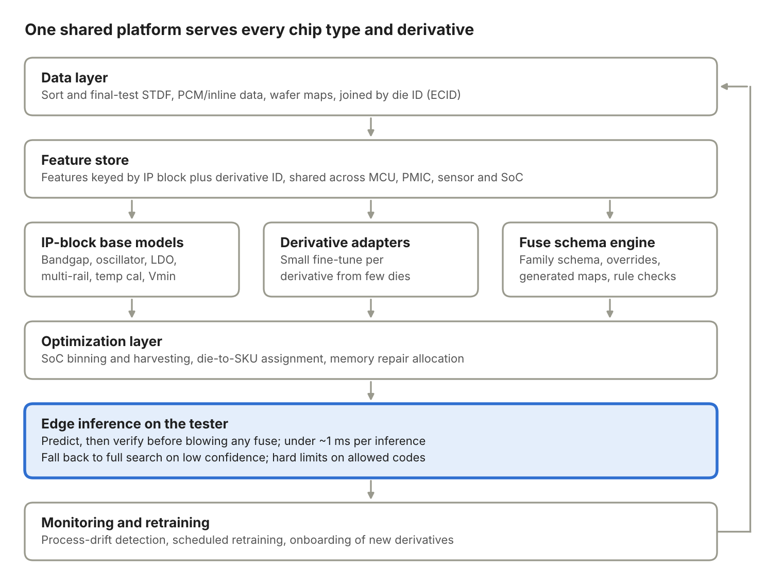
Platform architecture: six layers with a feedback loop
Data flows down from test logs to the tester, where every prediction is verified before a fuse is blown; test results flow back up to retrain the models. Models are exported to ONNX or lookup tables for Advantest or Teradyne testers.

Metrics, safeguards and rollout
Start with one high-volume shared IP block, prove the savings with hard metrics, and never let a prediction blow a fuse without verification.
Metrics to track
Metric | What it shows
Trim test time per die | Direct test-cost saving
First-pass trim hit rate | Model accuracy on the tester
Final-test centering (Cpk) | Whether drift-aware targets work
Yield | Net effect of trim, repair and binning
DPPM | Escapes; must not rise
New-derivative bring-up time | Value of transfer learning
Safeguards
- Fuses are OTP: always take a verification measurement before programming.
- Fall back to the conventional search when model confidence is low; enforce hard limits on allowed codes.
- Security and key fuses stay on deterministic, audited flows.
- Automotive (ISO 26262) and medical parts need explainable, version-locked models and documented fallback paths.
- Monitor for process drift and retrain on a regular cadence (per lot or week).
Rollout order
- MCU oscillator and bandgap trim: simplest, high volume, quick proof of savings.
- PMIC multi-rail trim and the OTP configuration generator.
- Sensor temperature-insertion reduction: largest cost saving, needs a good characterization dataset.
- SoC Vmin/AVS and harvesting optimization: most complex, highest revenue impact.

